**Plant access to belowground moisture allows sustained evapotranspiration during drought**

**Main Text**

**Box 1 | Simple evapotranspiration decay model to illustrate the advantages of plotting fET(CWD) instead of ET(t).**Weassume a 60-days dry down event with the following setup:

* The initial water available to plants across the rooting zone (S0) is 100 mm
* ET (termed T, since it’s only transpiration here) is a linear function of the water stored in the root zone at the time t (St)and is independent of VPD:

T = α S(t) / S0

* The change in plant-available water storage is ΔS = T

This leads to an exponential decay of both S and VPD with time. We can set α = 0.01.  
We first study the relationship defined above with two different S0 (panels a-c). We set S0_shallow = 50 mm and S0_deep = 100 mm, as follows (panel b):

T = α S(t) / S0_shallow

T = α S(t) / S0_deep

We can see that when plotting fET(CWD), we distinguish two different lines (panel c). The intersect of the respective lines with the x-axis corresponds to the S0 defined in the two cases (50 mm and 100 mm).

We then compare the same relationship but with two different plant strategies. We set αconservative = 1 and αexploitative = 1.5, as follows (panel e):

T = αconservative S(t) / S0

T = αexploitative S(t) / S0

We can see that the fET(CWD) relationship is the same in the two cases. We can thus conclude that the fET metric factors out differences in plant strategies when plotted against the CWD (panel f). Our evaluation eliminates effects by distinct surface conductance across sites, and reveals the partial dependence on belowground water.

|  |  |
| --- | --- |
|  |  |
|  |  |

**Figure 1 | Performance of the deep-learning model at predicting evapotranspiration (ET).** ETNN and PETNN are respectively ET and PET predicted with our deep learning model. ETobs corresponds to observational ET from FLUXNET2015. **a**,ETNN vs ETobs, evaluated on all days. **b**,PETNN vs ETobs, evaluated on moist days only. **c**,PETPT is from the SPLASH model, based on a Priestley-Taylor formulation of evapotranspiration, vs ETobs **d**, PETlm is based on a linear model (lm), defined as PET=k*Rn, where *Rn* was converted to mass units (mm d-1) and *k* is a site-specific constant that scales *Rn*, calibrated to ETobs.

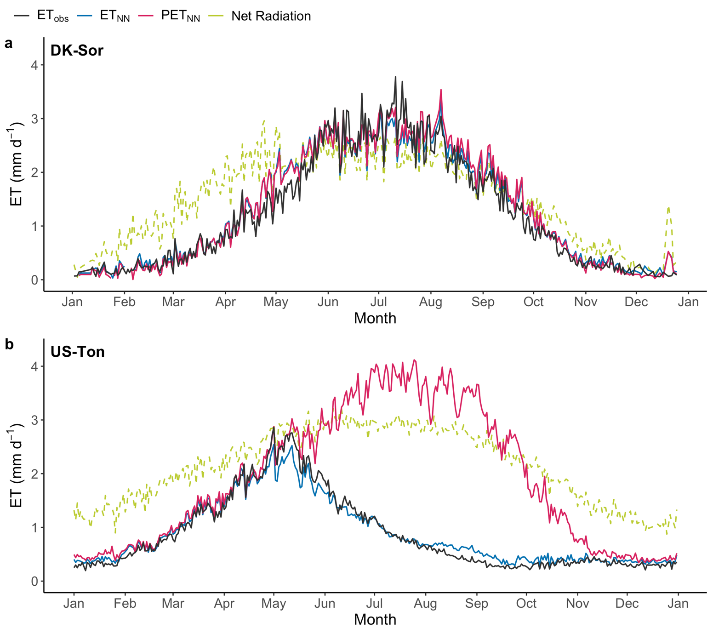

**Figure 2 | Seasonality of predicted and observed ET for sample sites. a,** DK-Sor **b,** US-Ton. ETNN and PETNN are respectively ET and PET predicted with our deep learning model. ETobs corresponds to observational ET from FLUXNET2015. Blue line: ETNN. Green line: PETNN. Red line: ETobs. Dashed gray line: Net radiation converted to mass units (mm d-1). We derived the seasonality by calculating the mean across all years for every day of the year.

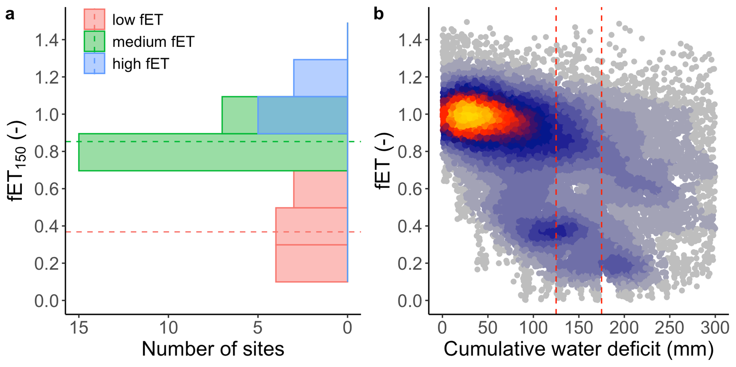

**Figure 3 | Partition of sites in three groups according to their median fET at CWD = 150 mm. a,** Number of sites per each fET group: low fET (red), medium fET (green), high fET (blue). Dashed lines represent the average fET inside each group.The width of each bin was determined with the Freedman-Diaconis rule, that considers size and spread of each sample. **b,** fET for all sites plotted against the cumulative water deficit (CWD). Dashed lines at CWD = 125 mm and CWD = 175 mm delimit the interval (fET150) in which the median of fET was calculated for each site to define the three fET groups (low fET, medium fET and high fET).

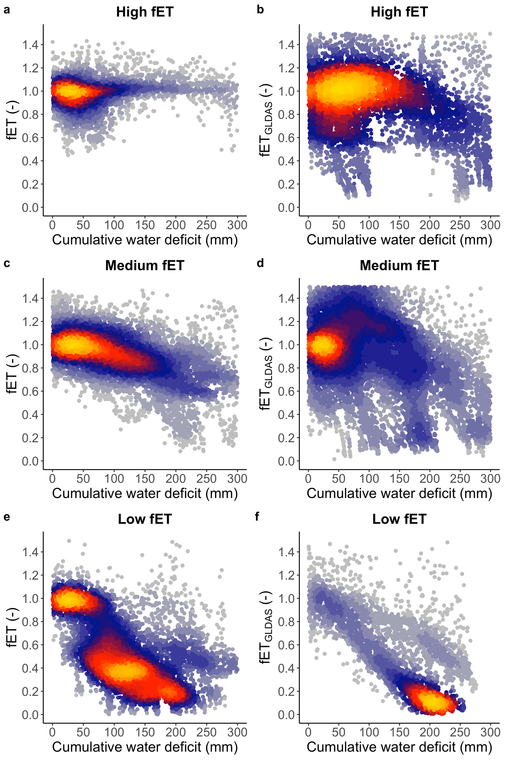

**Figure 4 | fET vs CWD for sites grouped according to their median fET**. **a**,**b** High fET, fET predicted from our observations-driven model (**a**) and extracted as ET/PET from the GLDAS data product (**b**). **c**,**d** Medium fET, fET predicted from our observations-driven model (**c**) and extracted as ET/PET from the GLDAS data product (**d**). **e,f** Low fET, fET predicted from our observations-driven model (**e**) and extracted as ET/PET from the GLDAS data product (**f**). PET from GLDAS was scaled by dividing it by its median in the lower CWD bin (CWD < 20 mm).

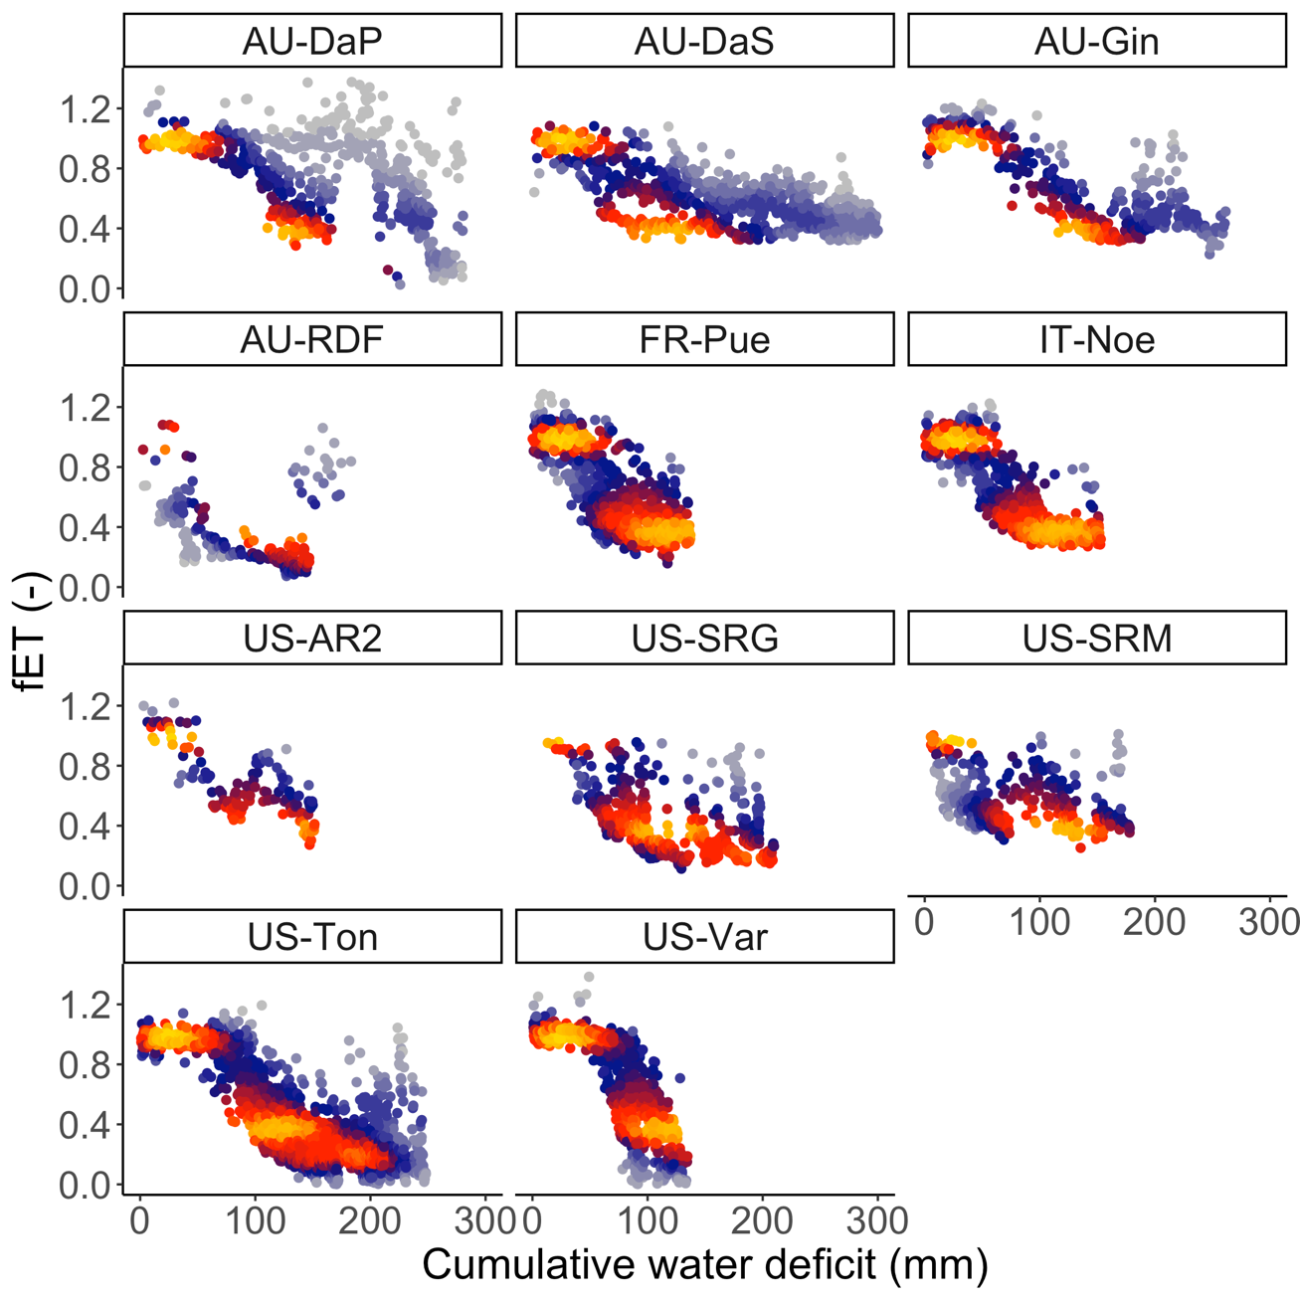

**Figure 5 | fET vs CWD for sites grouped according to their median fET.** Low fET group.

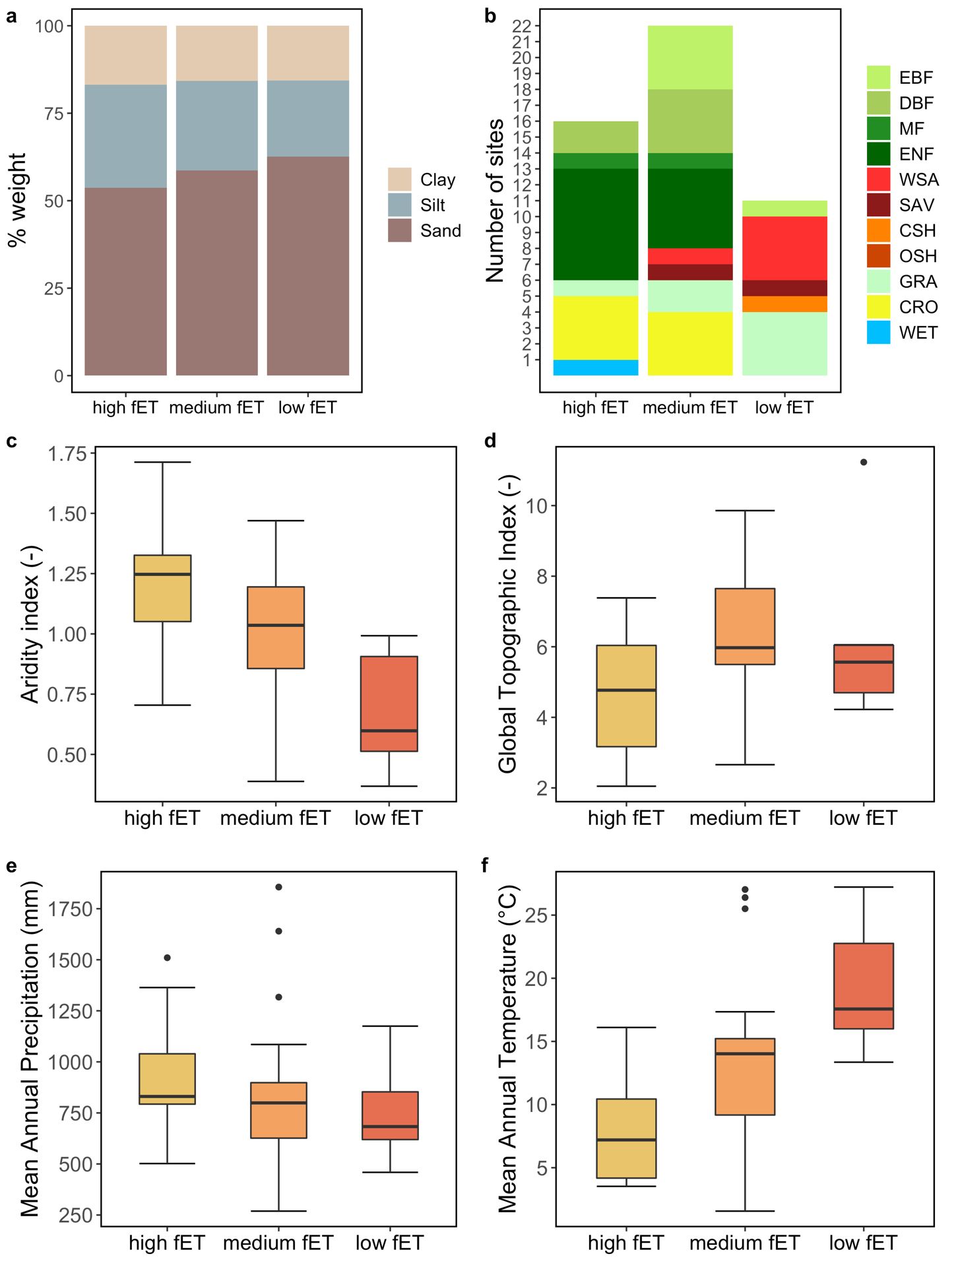

**Figure 6 | Analysis of soil and climate variables per fET group**. **a,** Topsoil soil texture in percentage weight. The mean was calculated across all sites within a certain fET group. **b,** IGBP vegetation classes (GRA, grasslands; SAV, savannah; WSA, woody savannah; ENF, evergreen needleleaf forest; EBF, evergreen broadleaf forest; DBF, deciduous broadleaf forest; CSH, closed shrubland; WET, wetland; CRO, cropland; MF, mixed forest). **c**, Aridity index, defined as the ratio of annual precipitation (P) over potential evapotranspiration (PET), calculated for all available years on a site-by-site basis. Precipitation data was taken from the FLUXNET2015 dataset, whereas PET was calculated with the SPLASH model, based on a Priestley-Taylor formulation of evapotranspiration. **d**, Global topographic index (GTI), defining the tendency of the soil to become saturated with water because of its topographic position. **e**, Mean Annual Precipitation. **f**, MAT, Mean Annual Temperature.

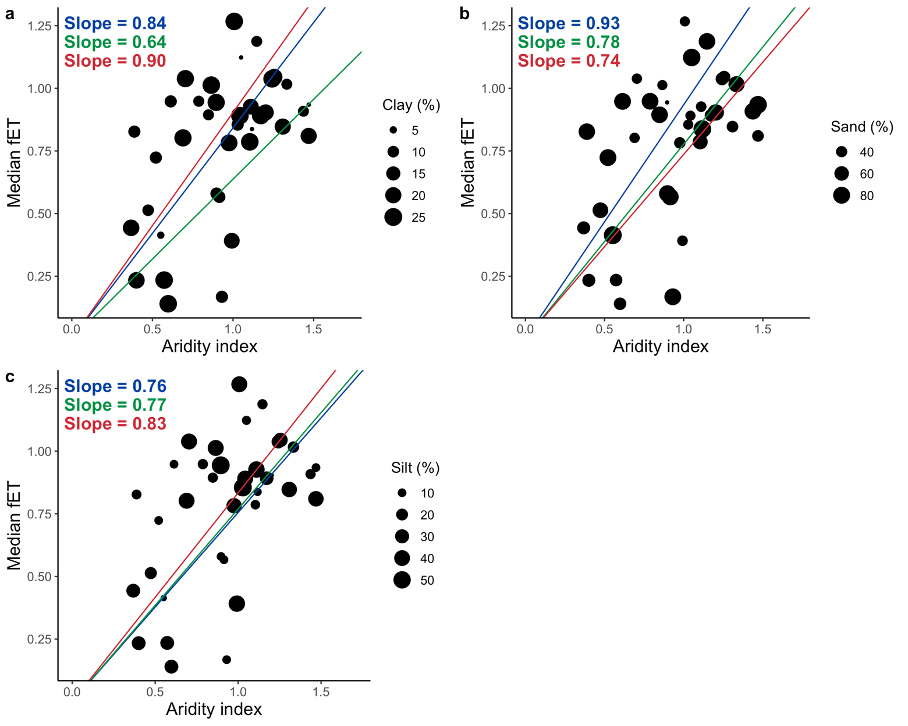

**Figure 7 | Median fET as a function of the aridity index per site**. Each dot represents one site. Circles size indicates soil texture (in percentage weight). The colored lines show the regression between the site-specific median fET and the aridity index, divided in three equal-sized groups of soil texture fractions (in ascending order, from lower to higher soil fraction: blue, green and red lines). Slopes values were tested to be statistically significant (t-test with a significance level of 0.05). **a,** Clay fraction **b,** Sand fraction. **c**, Silt fraction. All soil fractions are from the topsoil.

**Supplementary Information**

|  |  |  |  |  |  |  |
| --- | --- | --- | --- | --- | --- | --- |
| **Site** | **Coordinates** | **Years** | **IGBP** | **fET group** | **MAT (**°C) | **MAP (mm)** |
| **AU-Cpr** | 140.59, -34 | 2010 - 2014 | SAV | medium fET | 17.35 | 269 |
| **AU-Cum** | 150.72, -33.61 | 2012 - 2014 | EBF | medium fET | 17.28 | 850 |
| **AU-DaP** | 131.32, -14.06 | 2007 - 2013 | GRA | low fET | 27.22 | 1175 |
| **AU-DaS** | 131.39, -14.16 | 2008 - 2014 | SAV | low fET | 27.13 | 1134 |
| **AU-Gin** | 115.71, -31.38 | 2011 - 2014 | WSA | low fET | 18.53 | 697 |
| **AU-How** | 131.15, -12.49 | 2001 - 2014 | WSA | medium fET | 27.03 | 1640 |
| **AU-RDF** | 132.48, -14.56 | 2011 - 2013 | WSA | low fET | 26.98 | 958 |
| **AU-Stp** | 133.35, -17.15 | 2008 - 2014 | GRA | medium fET | 26.39 | 639 |
| **AU-Wom** | 144.09, -37.42 | 2010 - 2012 | EBF | medium fET | 10.70 | 1071 |
| **BE-Vie** | 6, 50.31 | 1996 - 2014 | MF | medium fET | 8.01 | 1085 |
| **BR-Sa3** | -54.97, -3.02 | 2000 - 2004 | EBF | medium fET | 25.50 | 1856 |
| **CH-Dav** | 9.86, 46.82 | 1997 - 2014 | ENF | high fET | 3.53 | 1053 |
| **DE-Geb** | 10.91, 51.1 | 2001 - 2014 | CRO | medium fET | 8.96 | 496 |
| **DE-Kli** | 13.52, 50.89 | 2004 - 2014 | CRO | NA | 7.61 | 839 |
| **DE-Lkb** | 13.3, 49.1 | 2009 - 2013 | ENF | NA | 4.20 | 1364 |
| **DE-Obe** | 13.72, 50.78 | 2008 - 2014 | ENF | NA | 6.09 | 820 |
| **DE-Seh** | 6.45, 50.87 | 2007 - 2010 | CRO | medium fET | 10.17 | 709 |
| **DE-Tha** | 13.57, 50.96 | 1996 - 2014 | ENF | NA | 8.26 | 754 |
| **DK-Sor** | 11.64, 55.49 | 1996 - 2014 | DBF | medium fET | 8.48 | 614 |
| **FR-LBr** | -0.77, 44.72 | 1996 - 2008 | ENF | medium fET | 12.52 | 908 |
| **FR-Pue** | 3.6, 43.74 | 2000 - 2014 | EBF | low fET | 13.35 | 683 |
| **IT-BCi** | 14.96, 40.52 | 2004 - 2014 | CRO | high fET | 16.10 | 1035 |
| **IT-CA3** | 12.02, 42.38 | 2011 - 2014 | DBF | medium fET | 14.52 | 328 |
| **IT-Col** | 13.59, 41.85 | 1996 - 2014 | DBF | medium fET | 6.95 | 789 |
| **IT-Cpz** | 12.38, 41.71 | 1997 - 2009 | EBF | medium fET | 15.54 | 757 |
| **IT-Lav** | 11.28, 45.96 | 2003 - 2014 | ENF | NA | 6.79 | 502 |
| **IT-Noe** | 8.15, 40.61 | 2004 - 2014 | CSH | low fET | 15.85 | 748 |
| **IT-Ren** | 11.43, 46.59 | 1998 - 2013 | ENF | NA | 3.98 | 664 |
| **IT-Ro2** | 11.92, 42.39 | 2002 - 2012 | DBF | medium fET | 14.54 | 380 |
| **IT-SR2** | 10.29, 43.73 | 2013 - 2014 | ENF | medium fET | 14.02 | 888 |
| **IT-SRo** | 10.28, 43.73 | 1999 - 2012 | ENF | medium fET | 14.02 | 888 |
| **IT-Tor** | 7.58, 45.84 | 2008 - 2014 | GRA | medium fET | 1.56 | 1317 |
| **NL-Loo** | 5.74, 52.17 | 1996 - 2013 | ENF | medium fET | 9.38 | 839 |
| **RU-Fyo** | 32.92, 56.46 | 1998 - 2014 | ENF | medium fET | 4.51 | 693 |
| **US-AR2** | -99.6, 36.64 | 2009 - 2012 | GRA | low fET | 14.22 | 600 |
| **US-ARb** | -98.04, 35.55 | 2005 - 2006 | GRA | high fET | 15.29 | 793 |
| **US-ARM** | -97.49, 36.61 | 2003 - 2012 | CRO | medium fET | 14.90 | 861 |
| **US-Blo** | -120.63, 38.9 | 1997 - 2007 | ENF | high fET | 11.04 | 1510 |
| **US-Los** | -89.98, 46.08 | 2000 - 2014 | WET | NA | 4.12 | 833 |
| **US-MMS** | -86.41, 39.32 | 1999 - 2014 | DBF | high fET | 11.13 | 1097 |
| **US-Ne1** | -96.48, 41.17 | 2001 - 2013 | CRO | high fET | 10.24 | 799 |
| **US-Ne2** | -96.47, 41.16 | 2001 - 2013 | CRO | medium fET | 10.21 | 799 |
| **US-Ne3** | -96.44, 41.18 | 2001 - 2013 | CRO | high fET | 10.20 | 793 |
| **US-SRG** | -110.83, 31.79 | 2008 - 2014 | GRA | low fET | 17.57 | 537 |
| **US-SRM** | -110.87, 31.82 | 2004 - 2014 | WSA | low fET | 18.53 | 459 |
| **US-Syv** | -89.35, 46.24 | 2001 - 2014 | MF | NA | 3.76 | 844 |
| **US-Ton** | -120.97, 38.43 | 2001 - 2014 | WSA | low fET | 16.14 | 656 |
| **US-Var** | -120.95, 38.41 | 2000 - 2014 | GRA | low fET | 16.20 | 639 |
| **US-WCr** | -90.08, 45.81 | 1999 - 2014 | DBF | high fET | 4.23 | 828 |

**Table 1. FLUXNET Tier 1 sites included in the analysis.** *Group* refers to the grouping of sites according to their median fET (see Methods). *Coordinates* in decimal degrees. *IGBP* is the vegetation class (GRA, grasslands; SAV, savannah; WSA, woody savannah; ENF, evergreen needleleaf forest; EBF, evergreen broadleaf forest; DBF, deciduous broadleaf forest; CSH, closed shrubland; WET, wetland; CRO, cropland; MF, mixed forest). *MAT*, mean annual temperature (°C). *MAP*, mean annual precipitation (mm).

|  |  |
| --- | --- |
|  |  |

**Supplementary Figure 2 | Performance of the deep-learning model at predicting evapotranspiration (ET) across sites.** ETNN and PETNN are respectively ET and PET predicted with our deep learning model. ETobs corresponds to observational ET from FLUXNET2015. **a**,PETNN vs ETNN, evaluated on moist days. **b**, PETNN vs observational ETobs, evaluated on dry days.

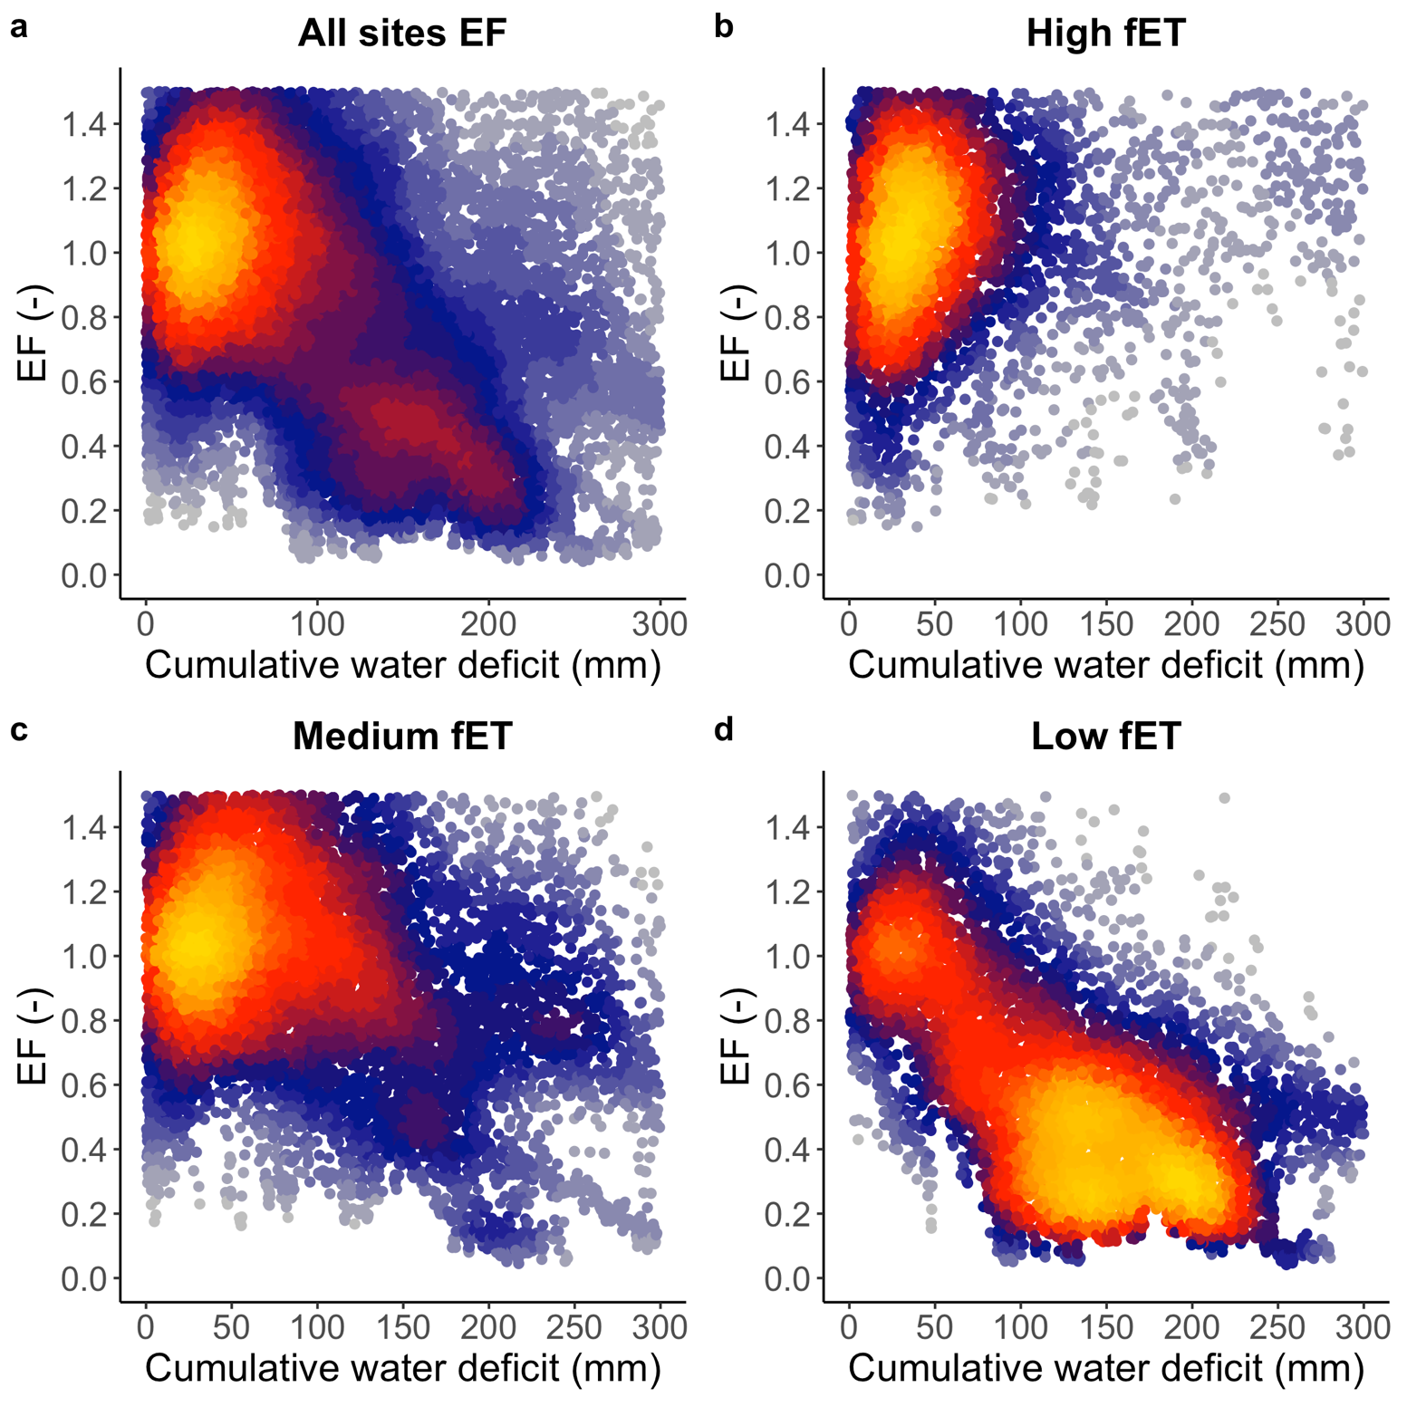

**Supplementary Figure 2 | EF vs CWD for sites grouped according to their median fET**. **a**, All sites. **b**, High fET. **c**, Medium fET. **d,** Low fET. The clustering is consistent with Figure 3. EF was scaled by dividing it by the median in its lower CWD bin (CWD < 20 mm). EF was calculated as latent heat divided by net radiation, two quantities directly downloaded from the FLUXNET2015 dataset that do not depend on any model.

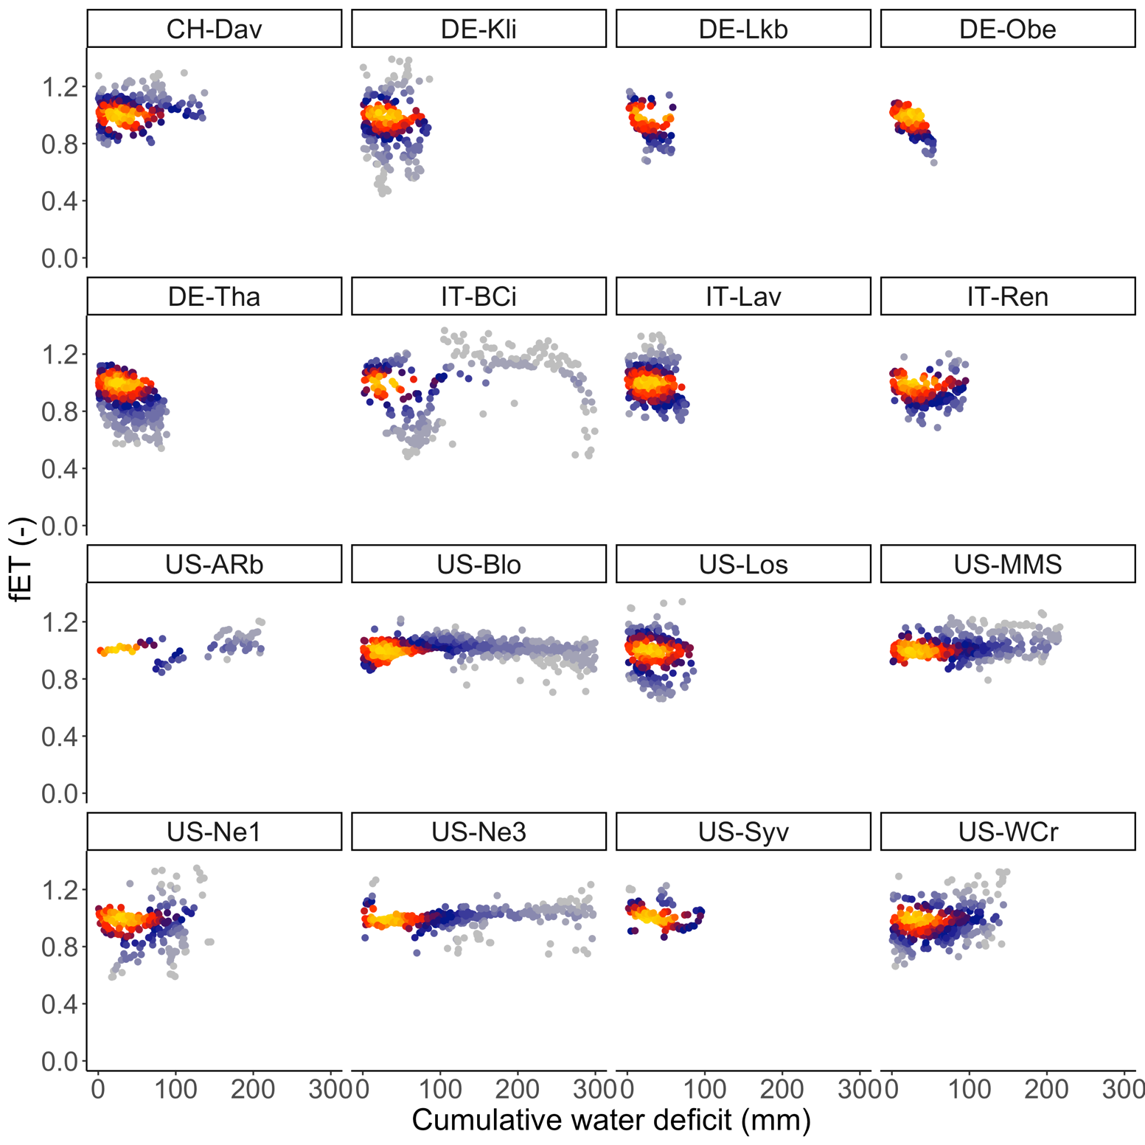

**Supplementary Figure 3 | fET vs CWD for sites grouped according to their median fET.** High fET group.

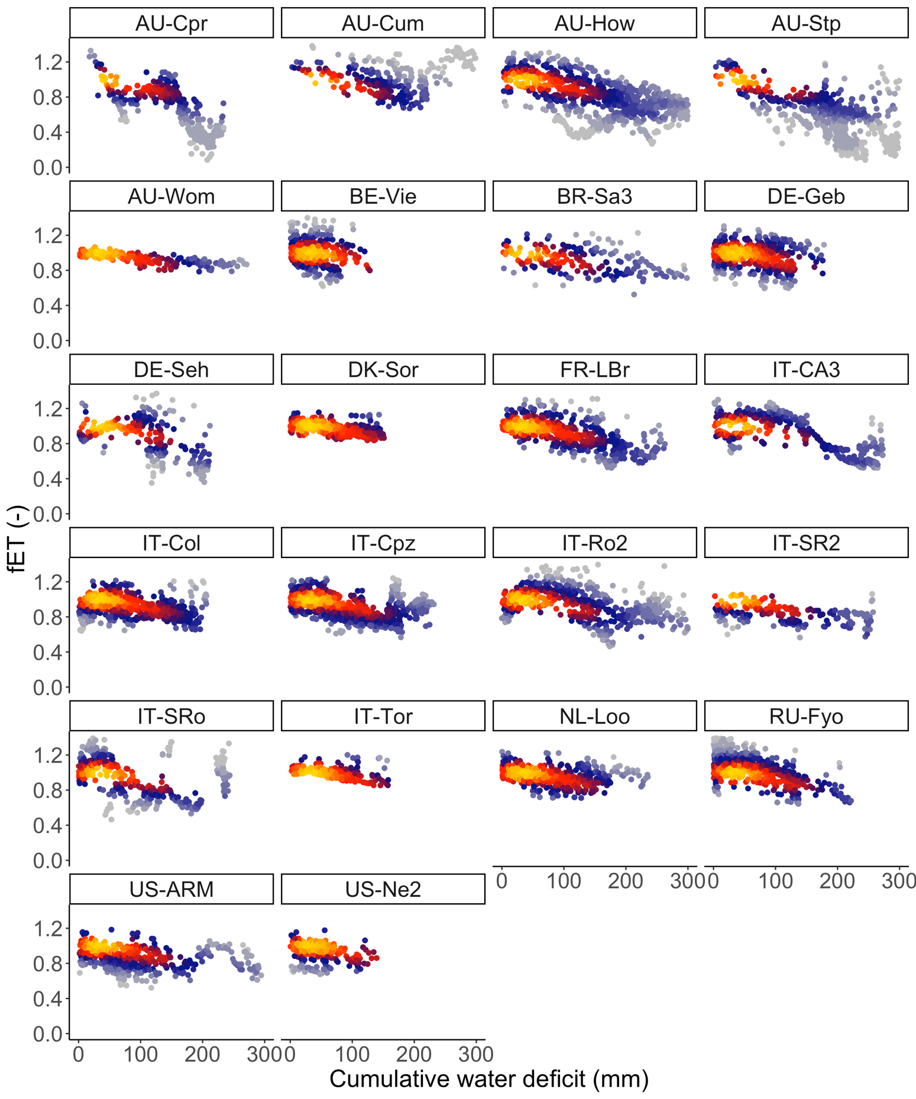

**Supplementary Figure 4 | fET vs CWD for sites grouped according to their median fET.** Medium fET group.